Name:_______________________________________ Date:__________________________________

1. Identify (circle) the locations of firefighting appliances on the plan;

2. Traces the escape routes and identify the most direct escape routes from the locations on the plan:

1. 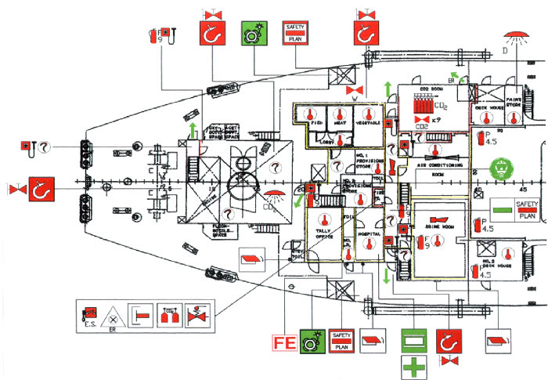CO2 Room
2. Crew mess area
3. Engine room
4. Stateroom
5. Hospital

**Engine Room**

**Hospital**

**Crew Mess Area**

**Stateroom**

CO2 Room